NAME : Pushti Shah SAP ID: 60019210097
ROLL NO: B074 SUB: Network Security
EXPERIMENT 3
Aim: Implementation of Secure Wireless LAN for Home and Enterprise Networks

Scenario A - Secure Home Network (WPA2-Personal):
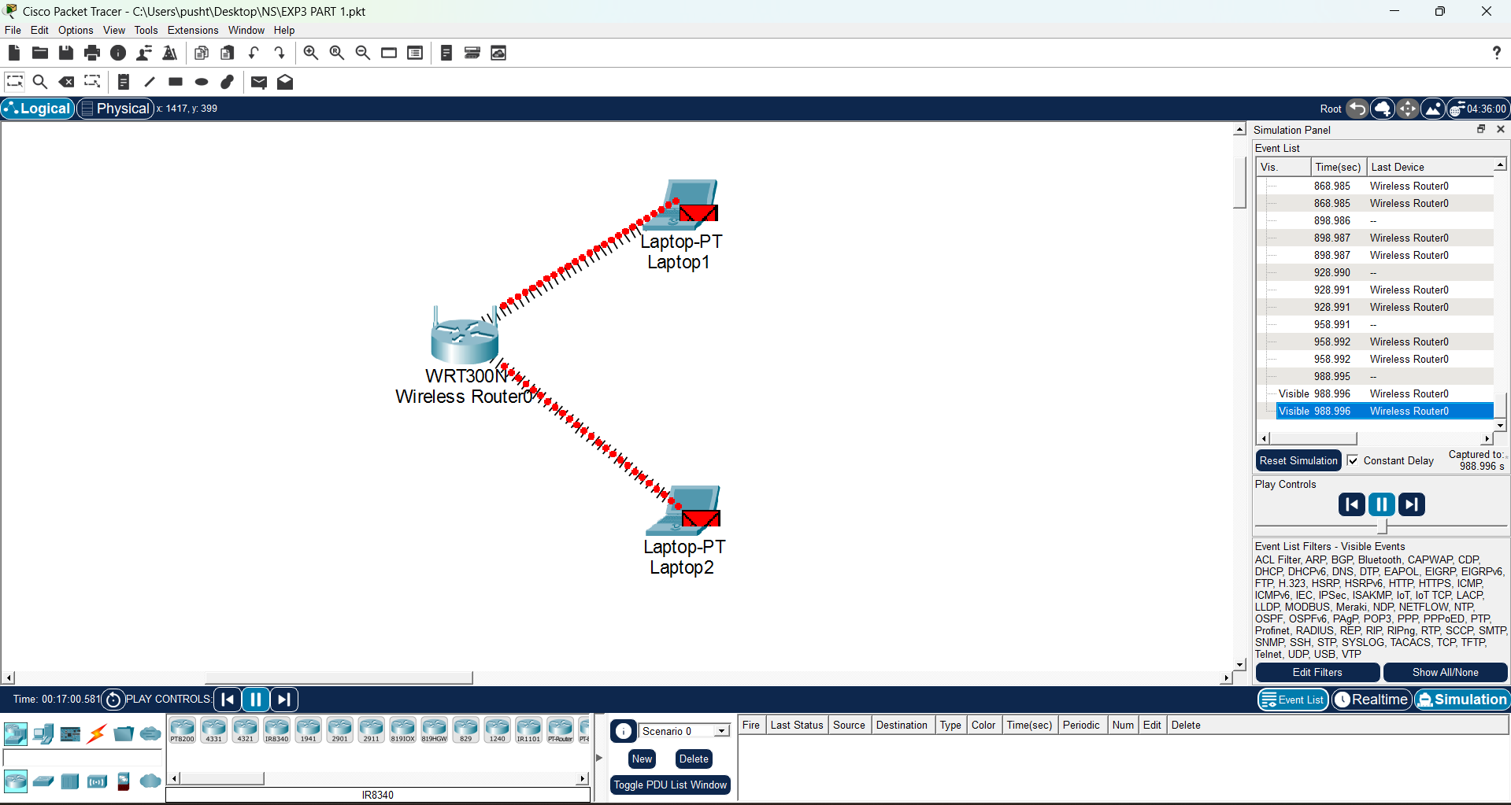

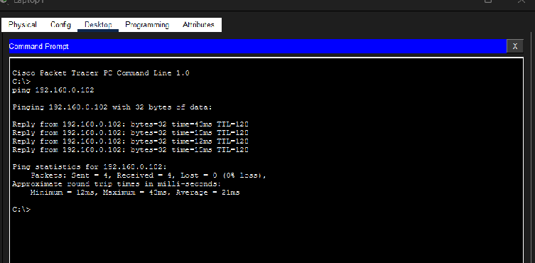

Scenario B - Enterprise Wireless LAN (WPA2-Enterprise):
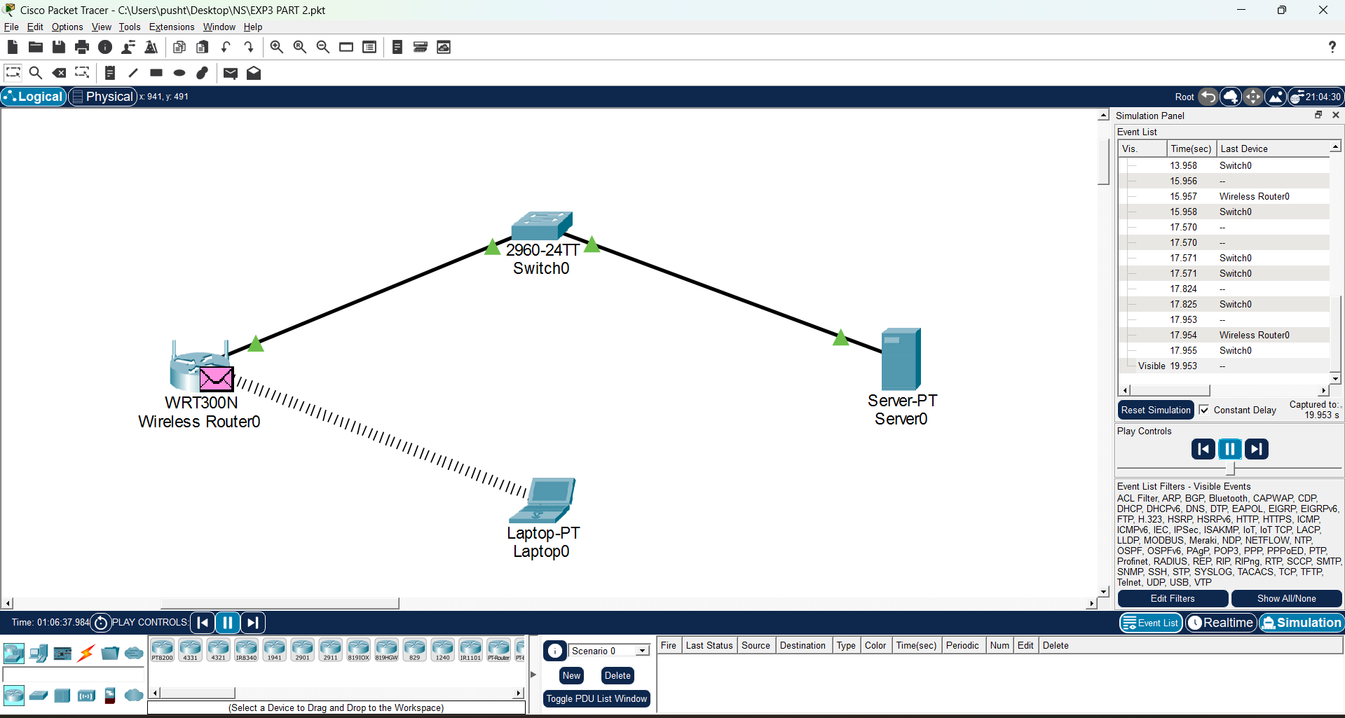

Conclusion:
In this experiment, we successfully designed and implemented both secure Home and Enterprise Wireless LANs using Cisco Packet Tracer.
In Scenario A (Home Network), we configured a wireless network using WPA2-Personal (PSK) security. By connecting multiple laptops to the same SSID and verifying communication using the ping command. This demonstrated how WPA2-Personal provides basic security using a shared password.
In Scenario B (Enterprise Network), we implemented a more advanced WPA2-Enterprise (802.1X) security mechanism using a RADIUS server. Authentication was performed using individual user credentials, ensuring higher security. The successful connection of the client laptop proved that enterprise-level authentication was correctly configured.
Overall, this experiment highlighted the importance of wireless security in both home and enterprise environments. It demonstrated the difference between pre-shared key authentication and centralized authentication and showed how secure configurations help protect networks from unauthorized access while maintaining reliable connectivity.

